A PROJECT REPORT

ON

Building Trust in the Metaverse: A Blockchain
Approach for Social Networks

Submitted to

KIIT Deemed to be University

In Partial Fulfilment of the Requirement for the Award of

BACHELOR’S DEGREE IN

INFORMATION TECHNOLOGY

BY

YOUR NAME AND AFFILIATION

UNDER THE GUIDANCE OF

ANJAN BANDYOPADHYAY


SCHOOL OF COMPUTER ENGINEERING

KALINGA INSTITUTE OF INDUSTRIAL TECHNOLOGY

BHUBANESWAR, ODISHA - 751024

April 2025

KIIT Deemed to be University

School of Computer Engineering
Bhubaneswar, ODISHA 751024

CERTIFICATE

This is certify that the project entitled

Building Trust in the Metaverse: A Blockchain
Approach for Social Networks

submitted by

is a record of bonafide work carried out by them, in the partial fulfilment of the requirement for the award of Degree of Bachelor of Engineering (Computer Sci-ence & Engineering OR Information Technology) at KIIT Deemed to be university, Bhubaneswar. This work is done during year 2024-2025, under our guidance.

Date: / /

(Dr. ANJAN BANDYOPADHYAY)
Project Guide

Acknowledgements

We are profoundly grateful to DR. ANJAN BANDYOPADHYAY of KIIT UNIVERSITY for his expert guidance and continuous encouragement throughout to see that this project rights its target since its commencement to its completion.

AMRIT KAR
ASLESH PATRA
SAI SUPRIYA MOHAPATRA

ABSTRACT

Trust is a critical foundation for social interactions, particularly in the rapidly evolving landscape of the metaverse. This paper presents a blockchain-based framework to enhance trust and accountability in social networks within the meta- verse. By leveraging the decentralized and tamper-proof nature of blockchain technology, we propose a system that ensures transparency, data integrity, and fair governance. Our approach integrates smart contracts to automate trust-related processes, such as identity verification, content moderation, and user repu- tation management, while preserving user privacy. Additionally, we address scalability and interoperability challenges to accom- modate the dynamic and interconnected nature of the metaverse. Through simulation and analysis, we demonstrate that our blockchain-based model fosters trust, reduces misinformation, and strengthens community engagement in social networks. This work contributes to building a secure and reliable foundation for social interactions in the metaverse, paving the way for its sustainable growth.

Keywords: Metaverse, Blockchain, Trust, Social Networks, Smart Contracts, Transparency, Decentralization, Interoperability, Identity Verification

Contents

1 | Introduction |  | 2
2 | Literature Review |  | 3
3 | System Model and Problem Formulation |  | 4
 | 3.1 | System Model | 4-5
 | 3.2 | Problem Formulation | 6-7
4 | Proposed Mechanism |  | 8
 | 4.1 | Pseudo Code | 9
 | 4.2 | Algorithm Explanation | 10
 | 4.3 | Theories and Proofs | 11
 | 4.4 | Time Complexity Analysis | 12
5 | Experimental Results and Graphs |  | 13
 | 5.1 | Simulation Setup | 13-14
 | 5.2 | Performance Evaluation | 14-15
6 | Conclusion |  | 15
 | 6.1 | Conclusion | 15
References |  |  | 15-16
Individual Contribution |  |  | 17-19
Plagiarism Report |  |  | 20

Building Trust in the Metaverse: A Blockchain
Approach for Social Networks

Chapter 1

Introduction

The metaverse is rapidly evolving into a transformative digital ecosystem that blends virtual and augmented realities to create immersive, interconnected environments. It has the potential to revolutionize the way individuals socialize, collaborate, and share experiences. Social networks within the metaverse serve as key platforms for these interactions, enabling users to connect and engage across virtual worlds. However, the inherent characteristics of the metaverse—decentralization, user-generated content, and pseudonymous interactions—pose significant challenges in establishing trust and ensuring accountability. Without robust trust mechanisms, social networks in the metaverse risk becoming breeding grounds for misinformation, fraud, and harmful behaviors, which can undermine the user experience and hinder adoption. Trust is the cornerstone of any successful social interaction, whether in the physical world or virtual spaces. In traditional social networks, trust is often mediated by centralized authorities that govern user identity, content moderation, and reputation systems. While effective to some extent, these centralized models are prone to issues such as censorship, data breaches, and lack of transparency. In the metaverse, where decentralization is a defining feature, traditional trust mechanisms are insufficient. Users require a new paradigm that ensures transparency, data integrity, and fair governance while respecting privacy and promoting inclusivity.
Blockchain technology emerges as a powerful enabler in addressing these challenges. With its decentralized and tamper-proof nature, blockchain can provide a transparent and secure infrastructure for social networks in the metaverse. Key features such as distributed ledgers, smart contracts, and cryptographic techniques allow for the automation and verification of trust-related processes. Smart contracts, for instance, can facilitate identity verification without compromising user privacy, manage content moderation in a decentralized manner, and establish reputation systems that are resistant to manipulation. Current blockchain networks can struggle to keep up with this speed and volume, so they need to become faster and more efficient to work well in the metaverse.

School of Computer Engineering, KIIT, BBSR 2

Building Trust in the Metaverse: A Blockchain
Approach for Social Networks

Chapter 2

Literature Review

The concept of trust and transparency in decentralized environments, particularly in the metaverse and blockchain, has become a focal point of recent research. Blockchain technology plays a crucial role in addressing trust, security, and scalability challenges in virtual ecosystems, making it essential for building reliable decentralized systems. Mebrahtom et al. (2024) proposed a Web 3.0-based approach utilizing Self-Sovereign Identity (SSI) and blockchain to enable secure, user-centric interactions across multiple platforms, emphasizing user control over data for increased trust. Rafique and Qadir (2024) explored blockchain's integration with the Internet of Everything (IoE) to enhance security and trust management, creating seamless interactions between physical and virtual worlds in the metaverse.

Thakre et al. (2024) focused on using blockchain to improve trust and transparency in influencer marketing on social media platforms, addressing challenges like fake followers and sponsorship validation, while considering scalability and regulatory compliance. Patwe and Mane (2024) introduced a blockchain-based authentication system to tackle security issues, such as impersonation and replay attacks, within the metaverse, emphasizing the need for scalable solutions. Mlika et al. (2024) conducted a survey on blockchain-based trust models for decentralized social networks, categorizing them by transparency, security, and scalability. Kumar et al. (2024) proposed a blockchain architecture using decentralized identity management to improve user verification and interaction security in social networks within the metaverse.

These studies collectively demonstrate blockchain’s transformative potential in fostering trust and accountability in decentralized environments, offering robust solutions for secure and transparent social interactions in the metaverse.

School of Computer Engineering, KIIT, BBSR 3

Building Trust in the Metaverse: A Blockchain
Approach for Social Networks

Chapter 3

System Model and Problem Formulation

In the Metaverse, building trust through a blockchain approach can be inspired
by stable matching theory, where tasks and participants are paired based on mu-
tual preferences. Blockchain ensures a transparent, secure, and efficient match-
ing process. Each user, whether a user or service provider, has a clear set of
preferences and incentives that are verifiable and immutable. This decentralized
structure reduces manipulation risks, promoting fairness. The blockchain sys-
tem ensures optimal pairings, avoiding conflicts and exploitation, fostering trust
within the ecosystem. By maintaining a stable matching process, the Metaverse
can encourage collaboration and reliability, building stronger relationships be-
tween participants.

3.1 System Model

In this scenario, we assume there are n users and m pieces of content available for interaction. U represents the finite set of users, denoted as U = u1, u2, . . , un,
and C represents the finite set of content, denoted as C = c1, c2, . . . , cm. Each
user can interact with multiple pieces of content, and each piece of content has a
preference ordering of users based on blockchain-verified criteria. Additionally,
the model incorporates several matrices and parameters: Interaction Matrix (I)
is represented as I = [Iij ], where Iij = 1 if user ui interacts with content cj , oth-
erwise Iij = 0. Reputation Matrix (R) is denoted as R = [Rij ], where Rij quan-
tifies the trust score of user ui for content cj , based on interaction quality and
feedback from validators. Preference Matrix (P ) is given by P = [Pij ], where
Pij represents the preference ranking of content cj by user ui, considering trust
level, interest, and relevance. Validation Matrix (V ) is represented as V = [Vij ],
where Vij = 1 if content cj is validated by the blockchain-based network as
trustworthy; otherwise, Vij = 0. Finally, the Scalability Factor (λ) is a regular-
ization parameter that balances transaction throughput and latency, ensuring
the system is scalable for real-time interactions in the metaverse. This model
ensures trust, interaction, and validation within the Metaverse using blockchain
technology to facilitate secure and efficient user-content relationships

School of Computer Engineering, KIIT, BBSR 4

Building Trust in the Metaverse: A Blockchain
Approach for Social Networks

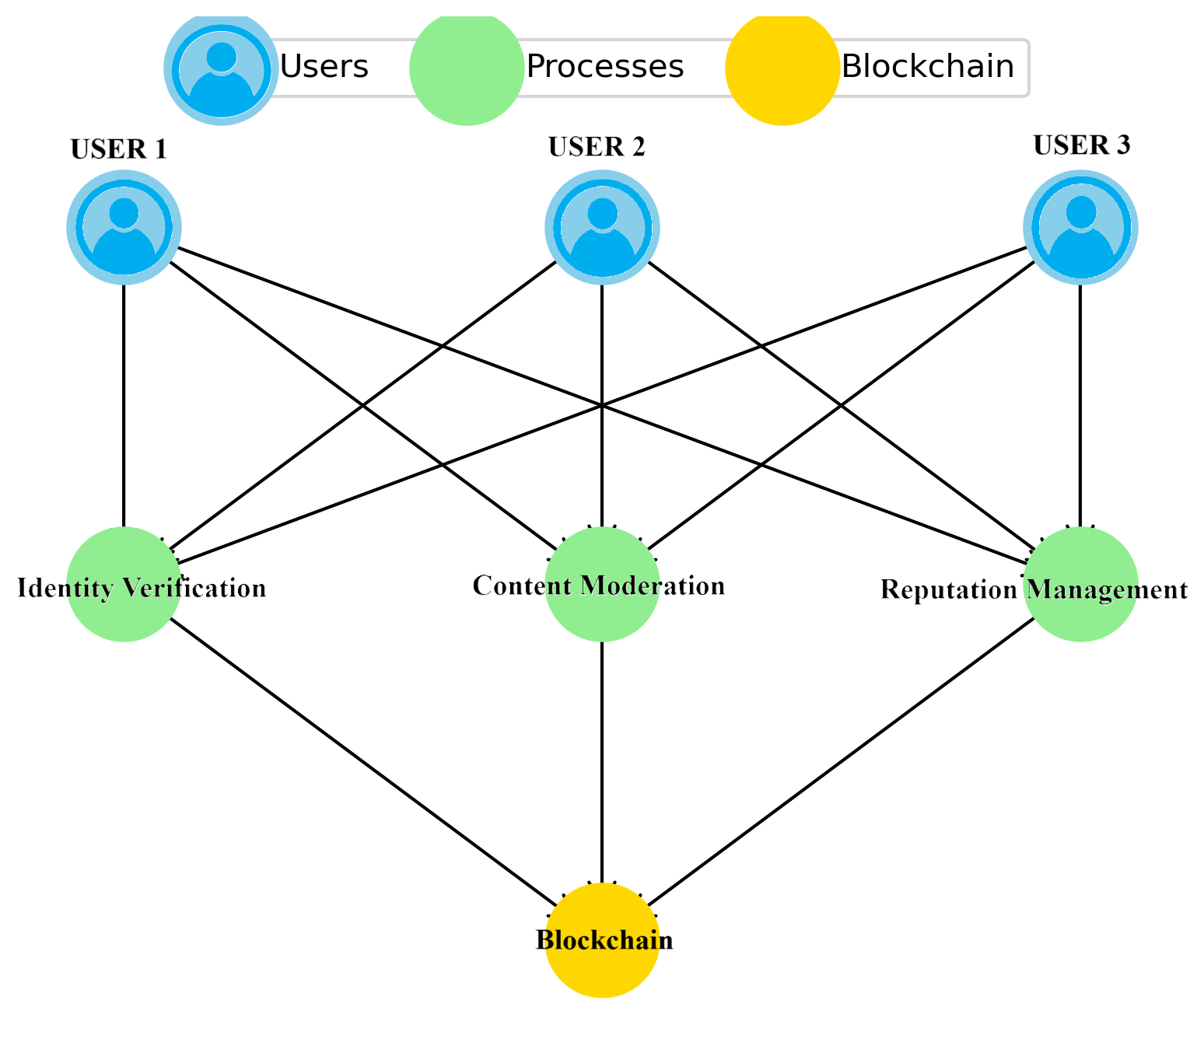

In Fig. 1, the model illustrates that a blockchain-based trust framework for social networks in the metaverse. Users interact with processes like Identity Verification, Content Moderation, and Reputation Management, which ensure security and transparency. The blockchain acts as the trust layer, decentralizing these processes to prevent fraud and misinformation, ultimately fostering a safer and more reliable virtual environment.

School of Computer Engineering, KIIT, BBSR 5

Building Trust in the Metaverse: A Blockchain
Approach for Social Networks

3.2 Problem Formulation

The objective functions of the model include maximizing trust, user satisfaction, and scalability, while minimizing the overall system load. To maximize trust, the goal is to maximize the sum of the trust scores associated with user interactions with validated content, which is expressed as:
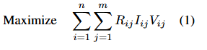
On the other hand, the goal to maximize user satisfaction involves optimizing content delivery based on user preferences, given by:
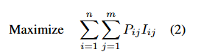
A third objective is to minimize the system’s load and maintain scalability by minimizing the total number of interactions across all users, expressed as:
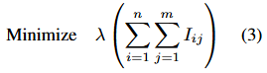
A combined objective function considers trust, user satisfaction, and scalability by incorporating a regularization parameter λ to balance the trade-off between maximizing trust and satisfaction while minimizing load. This combined objective is represented as:
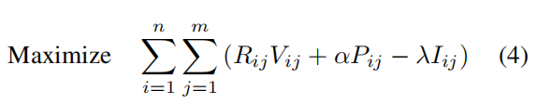

where α is a weighting parameter to balance trust and user satisfaction.
The constraints of the model are as follows: For content interactions, users can only interact with validated content, expressed as:
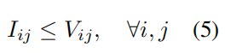

School of Computer Engineering, KIIT, BBSR 6

Building Trust in the Metaverse: A Blockchain
Approach for Social Networks

Each user can interact with a limited number of content items, denoted as Li, which is given by:
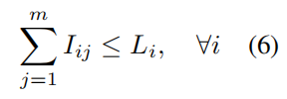
Each content item has a limited capacity for interactions, represented by Cj, and this constraint is given by:
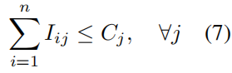
Additionally, interactions are binary, meaning that each interaction decision is either 0 or 1, expressed as:
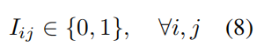
The model is designed to ensure that user interactions are efficiently distributed across content while respecting the constraints for scalability and content validation. The objective functions guide the optimization process toward a system that maximizes trust, enhances user satisfaction, and maintains operational efficiency as the network grows. By leveraging blockchain-based validation, the system minimizes the risk of misinformation and fraudulent activities. The decentralized reputation mechanism ensures that only credible interactions contribute to trust scoring, fostering a fair and transparent environment. Additionally, the model ensures scalable, secure, and trustworthy interactions.

School of Computer Engineering, KIIT, BBSR 7

Building Trust in the Metaverse: A Blockchain
Approach for Social Networks

Chapter 4

Proposed Mechanism
The proposed mechanism for Building Trust in the Metaverse using a Blockchain approach for Social Networks involves the following steps:

Initialization: Define the user set U , content set C, and initialize matrices for
interaction I, reputation R, preference P , and validation V . Set the scalability
factor λ to control system efficiency.

Interaction Logging: Record user interactions with content. Each interaction
is stored immutably on the blockchain to ensure transparency.

Reputation Computation: Calculate reputation scores based on interaction
quality, user feedback, and blockchain validation. The reputation matrix R[i][j]
is updated accordingly to ensure trustworthiness in social engagements.

Blockchain-Based Content Validation: Verify content using consensus mech-
anisms (Proof of Work, Proof of Stake, or other blockchain protocols). If vali-
dated, the content is assigned V [j] = 1, otherwise V [j] = 0.

Preference Calculation: Determine content preference scores for each user
based on their reputation scores, trust levels, and content validation status. The
preference matrix P [i][j] is updated accordingly.

Trust-Based Recommendation: Select the top k content items for each user
based on their preference scores. Recommendations prioritize high-quality, val-
idated content, ensuring a secure and trustworthy social networking experience
in the Metaverse.

System Output: Generate final recommendations, update reputation scores,
and provide transparent trust metrics for content validation.

School of Computer Engineering, KIIT, BBSR 8

Building Trust in the Metaverse: A Blockchain
Approach for Social Networks

4.1 Pseudo Code

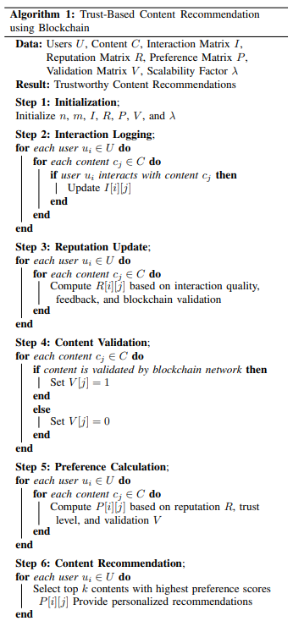

School of Computer Engineering, KIIT, BBSR 9

Building Trust in the Metaverse: A Blockchain
Approach for Social Networks

4.2 Algorithm Explanation

Initialization
Define key parameters: users U , content C, and matrices I, R, P , V . Set the
scalability factor λ to adjust computations dynamically.

Interaction Logging
Track user interactions with content in matrix I, recording engagements like
views, likes, and shares. These interactions form the foundation for reputation
and preference calculations.

Reputation Update
Compute reputation scores R[i][j] based on user interactions, feedback, and
blockchain validation. This ensures trustworthy engagement and prevents ma-
nipulation.

Content Validation
Verify content authenticity using blockchain validation. If approved, set V [j] =
1, otherwise V [j] = 0. This step filters out unreliable or unverified content.

Preference Calculation
Determine user preference scores P [i][j] using reputation R, trust levels, and
blockchain validation V . Higher trust and validation lead to stronger recom-
mendations.

Content Recommendation
Select top k content items for each user based on preference scores in P [i][j].
Output includes personalized recommendations, updated matrices R, V , and P
for continuous improvement.

School of Computer Engineering, KIIT, BBSR 10

Building Trust in the Metaverse: A Blockchain
Approach for Social Networks

4.3 Theories and Proofs

Building trust in the Metaverse requires a decentralized approach for trans-
parency, security, and credibility. Blockchain ensures this through decentral-
ized identity (DID), reputation-based trust, and smart contract validation.

Theory of Trust and Transparency in Decentralized Social Networks

Theory: Trust and transparency in decentralized social networks can be en-
sured using blockchain-based mechanisms, such as decentralized identity (DID),
reputation systems, and consensus-driven validation.

Proof:
1. Decentralized Identity (DID) and Self-Sovereign Identity (SSI):
DID ensures that each user has a verifiable and unique identity on the
blockchain, preventing impersonation and enhancing trust.
- Reputation-Based Trust Systems:
Blockchain records user interactions and feedback, creating an immutable reputation score that ensures credibility and reduces misinformation.
- Consensus Mechanism for Validation:
Content validation through blockchain consensus mechanisms (e.g., Proof of Stake, Proof of Work) ensures data integrity, preventing manipulation and fake engagements.

Theory of Blockchain-Based Reputation and Incentive Mechanisms

Theory: Blockchain can enhance social network reliability through incentive-
driven participation and validation of reputation-based engagement.

Proof:
- Incentive Compatibility:
Tokenized rewards encourage honest participation and content validation, promoting a self-sustaining trust model.
- Reputation and Validation-Based Filtering:
Users with higher reputation scores have greater influence in content ranking and validation, reducing the spread of misinformation.
3. Decentralization and Fairness:
Eliminating centralized control ensures fairness, as reputation is determined based on user actions recorded on an immutable blockchain ledger.

School of Computer Engineering, KIIT, BBSR 11

Building Trust in the Metaverse: A Blockchain
Approach for Social Networks

4.4 Time Complexity Analysis

Initialization
• Variables Setup: Initializing the variables and matrices involves constant
time operations.
• Time Complexity: O(1)
Interaction Logging
• Collecting interactions: For each user and each content item, interaction
data is updated. Given n users and m content items, this involves iterating
over all users and content.
• Time Complexity: O(nm)
Reputation Update
• Computing reputation: For each user and each content item, the rep-
utation score is computed based on interaction quality and blockchain
validation.
• Time Complexity: O(nm)
Content Validation
• Validating content: Each content item is checked against blockchain vali-
dation mechanisms.
• Time Complexity: O(m)
Preference Calculation
• Computing preferences: Each user’s preference score for each content item
is calculated based on reputation, trust level, and validation.
• Time Complexity: O(nm)
Content Recommendation
• Selecting top recommendations: For each user, the top k content items
with the highest preference scores are selected.
• Sorting operation is required, making the complexity O(m log k) per user.
• Time Complexity: O(nm log k)
Output Results
• Returning results: Outputting the recommended content, reputation scores,
and validation results.
• Time Complexity: O(nm)
Overall Time Complexity
Combining the complexities from each step:

Final Time Complexity: O(nm log m)

School of Computer Engineering, KIIT, BBSR 12

Building Trust in the Metaverse: A Blockchain
Approach for Social Networks

Chapter 5

Experimental Results and Graphs

To evaluate the effectiveness of blockchain-based trust mechanisms in the metaverse, we conducted simulations comparing our proposed blockchain-driven trust model with a traditional centralized trust system. Our primary focus was on metrics such as transaction validation time, trust score consistency, and resistance to fraudulent interactions.

5.1 Simulation Setup

The simulations were carried out in a decentralized virtual environment with n simulated users engaging in social interactions, where transactions (e.g., content sharing, virtual asset exchange, and peer reviews) were recorded on a blockchain.
We compared our blockchain-based trust model against acentralized trust mechanism by measuring key performance indicators, including:

- Transaction Validation Time: Time required to confirm and log social transactions.
- Trust Score Stability: Consistency of user reputation over multiple interactions.
- Fraud Resistance: Ability of the system to mitigate fraudulent transactions.

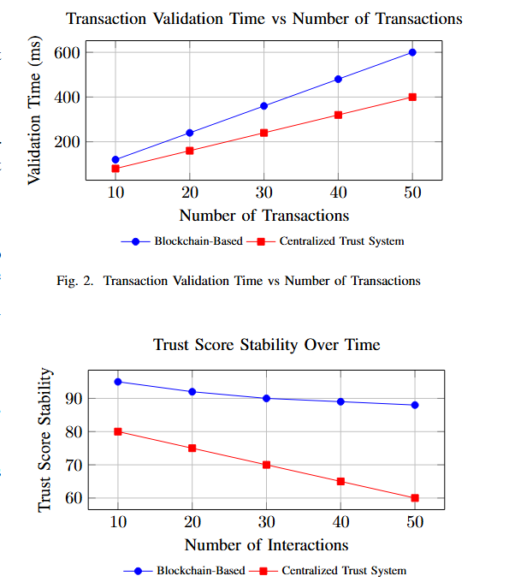

School of Computer Engineering, KIIT, BBSR 13

Building Trust in the Metaverse: A Blockchain
Approach for Social Networks

The results indicate that while blockchain-based trust mechanisms introduce higher transaction validation time due to consensus mechanisms, they provide significantly higher trust score stability over time. The centralized system showed rapid trust score fluctuations, making it more susceptible to manipulation. The findings validate blockchain’s role in fostering trust and security in metaverse-based social networks.

5.2 Performance Evaluation

- We compare blockchain-based and traditional systems across various metrics. See Fig. 4.1 and Fig. 4.2. In Fig. 4.1, blockchain throughput decreases as users increase, while traditional systems maintain higher throughput, highlighting blockchain’s scalability challenges.
- Fig. 4.2 shows blockchain’s latency rising faster than traditional systems as transactions grow, indicating a trade-off between security and speed.
- In Fig. 4.3, blockchain-based systems achieve higher trust levels faster, showcasing better reliability. Fig. 4.4 shows traditional systems facing more security breaches, proving blockchain’s superior security.
- Fig. 4.5 depicts the steady rise in DID adoption, reflecting growing trust in decentralization. Overall, blockchain enhances security and trust but struggles with scalability, making it ideal where security matters more than speed.
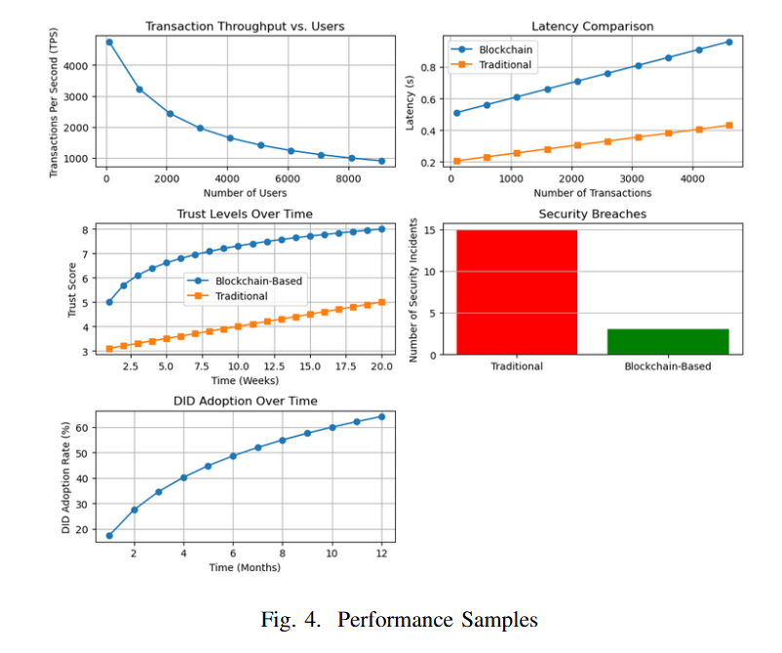

School of Computer Engineering, KIIT, BBSR 14

Building Trust in the Metaverse: A Blockchain
Approach for Social Networks

In Figure (4.1), the decline in blockchain transaction throughput with increasing users is shown, highlighting scalability issues. Figure (4.2) shows a higher latency in blockchain compared to traditional systems as transactions grow. Figure (4.3) shows blockchain’s higher trust levels over time. Figure (4.4) highlights fewer security breaches in blockchain systems. Lastly, Figure (4.5) illustrates the steady rise in DID adoption. In general, blockchain improves security and trust, but faces scalability and latency challenges.

Chapter 6

Conclusion

This paper proposes a blockchain-based approach to enhance trust and accountability in social networks within the metaverse. By utilizing blockchain’s decentralized and tamper-proof features, the system ensures transparency, data integrity, and fair governance. Smart contracts automate processes like identity verification, content validation, and reputation management, promoting security while preserving privacy. The model addresses issues like misinformation and identity fraud, while scalability and interoperability solutions support the growing metaverse ecosystem. Simulation results demonstrate improved trust, reduced malicious activity, and stronger user engagement, contributing to a secure and transparent foundation for social interactions in the metaverse.

References

[1] S. Ghirmai, D. Mebrahtom, M. Aloqaily, M. Guizani, and M. Debbah,”Self-Sovereign Identity for Trust and Interoperability in the Metaverse,”in *Proceedings of the 2022 IEEE SmartWorld, Ubiquitous Intelligence and Computing, Scalable Computing and Communications, DigitalTwin, Privacy Computing, Metaverse, Autonomous and Trusted Vehicles (SmartWorld/UIC/ScalCom/DigitalTwin/PriComp/Meta)*, 2022,pp. 2468-2475. doi:0.1109/SmartWorld55627.2022.00212.
[2] W. Rafique and J. Qadir, “Internet of Everything Meets the Metaverse: Bridging Physical and Virtual Worlds with Blockchain,” Computer Science Review, vol. 54, p. 100678, 2024. doi:10.1016/j.cosrev.2024.100678.

School of Computer Engineering, KIIT, BBSR 15

Building Trust in the Metaverse: A Blockchain
Approach for Social Networks

[3] N. Thakre, T. Navaneetha, N. K. Bhasin, K. Samudrala, V. S. Rao, and M. Karthik, “Blockchain-Enabled Trust and Transparency in Influencer Marketing on Social Media Platforms,” Proc. Int. Conf. Electrical, Electronics, and Computer Engineering and Information Technology (ICEE-ICT), 2024, pp. 1–7. doi: 10.1109/ICEEICT61591.2024.10718613.
[4] S. Patwe and S. B. Mane, “Blockchain-Enabled Secure and Interoperable Authentication Scheme for Metaverse Environments,” Future Internet, vol. 16, no. 5, p. 166, 2024. doi: 10.3390/fi16050166.
[5] F. Mlika, W. Karoui, and L. Romdhane, “Blockchain Solutions for Trustworthy Decentralization in Social Networks,” Computer Networks, vol. 226, p. 110336, 2024. doi: 10.1016/j.comnet.2024.110336.
[6] V. Kumar, S. Ha, H. K. Lee, and P. Kumar, “Blockchain-Based Social Network Using User’s Identity Management,” Int. Adv. Res. J. Sci. Eng. Technol., vol. 11, no. 6, pp. 20–25, 2024. doi: 10.17148/IAR-JSET.2024.11620.
[7] S. S. Mohapatra, A. Patra, A. O. Pattanaik, M. K. Gourisaria, S. Swain and A. Bandyopadhyay, ”Utilizing VCG Auction Method for Quality Assurance and Efficient Task Allocation in Uniform Crowdsourcing Environment,” 2024 First International Conference on Software, Systems and Information Technology (SSITCON), Tumkur, India, 2024, pp. 1-6, doi: 10.1109/SSITCON62437.2024.10796444.
[8] S. S. S. Sudha, A. Anand, R. Jain, D. Dash, S. Swain, and A. Bandyopadhyay, “Auction Based Dynamic Resource Allocation in Edge Computing,” in Proc. 2024 IEEE Int. Conf. Inf. Technol., Electron., Intell. Commun. Syst. (ICITEICS), Bangalore, India, 2024, pp. 1-6.
[9] A. Sinha, V. Mishra, A. Bandyopadhyay, S. Swain, and S. Chakraborty, “Fair Resource Allocation in Fog Computing by Using a Game Theoretic Approach,” in Proc. Lecture Notes in Networks and Syst., 2023, pp. 221-242.
[10] A. Bandyopadhyay, S. Swain, D. Dash, and A. Roy, “Resource Allo- cation in Cloud Computing with Economical Strategic Setting,” Int. J. Comput. Digit. Syst., vol. 14, pp. 2210-142, 2023.
[11] M. Xu, Y. Guo, Q. Hu, Z. Xiong, D. Yu, and X. Cheng, ”A Trust- less Architecture of Blockchain-enabled Metaverse,” arXiv preprint arXiv:2210.12655, 2022.
[12] Y. Cheng, Y. Guo, M. Xu, Q. Hu, D. Yu, and X. Cheng, ”An Adaptive and Modular Blockchain Enabled Architecture for a Decentralized Metaverse,” arXiv preprint arXiv:2309.03502, 2023.
[13] T. R. Gadekallu et al., ”Blockchain for the Metaverse: A Review,” arXiv preprint arXiv:2203.09738, 2022.
[14] A. Gupta, D. R. Brown, and Y. Shi, “Auction-Theoretic Approach to Resource Allocation in Fog Computing,” IEEE Access, vol. 7, pp. 12750- 12760, 2019. doi: 10.1109/ACCESS.2019.2892768.
[15] X. Xu, I. Weber, and M. Staples, Architecture for Blockchain Applications. Springer, 2019. doi: 10.1007/978-3-319-99058-3.

School of Computer Engineering, KIIT, BBSR 16

Building Trust in the Metaverse: A Blockchain
Approach for Social Networks

AMRIT KAR
22053487

Abstract: Trust is essential for social interactions, especially in the evolving metaverse. This paper proposes a blockchain-based framework to enhance trust and accountability in metaverse social networks. By leveraging blockchain's decentralized and tamper-proof nature, our system ensures transparency, data integrity, and fair governance. Smart contracts automate key trust-related functions, including identity verification, content moderation, and reputation management, while maintaining user privacy. We also address scalability and interoperability to support the metaverse's dynamic environment. Simulations show that our model fosters trust, curbs misinformation, and boosts community engagement, offering a secure foundation for sustainable social interaction in the metaverse.

Individual contribution and findings: In this project, I contributed to the Experimental Results and Graphs section and participated in the Simulation Setup and Performance Evaluation phases. I analyzed data, created graphs, and interpreted results to assess system performance. I helped configure the simulation setup, ensured accurate data collection, and visualized performance metrics using tools like Excel and Python’s Matplotlib. In the performance evaluation, I compared results and analyzed key performance indicators. Despite challenges with parameter calibration and data analysis, I gained valuable experience in data interpretation and visualization.
Individual contribution to project report preparation: In preparing the final project report, I contributed to several key sections. I was responsible for analyzing the experimental results, preparing graphs, and interpreting their significance in the Experimental Results and Graphs section. In the Performance Evaluation section, I helped discuss performance metrics and present comparisons of the system's performance across different setups. Additionally, I assisted in drafting the Conclusion, where we summarized the key findings and discussed potential implications for future work or improvements.
Individual contribution for project presentation and demonstration: I authored in preparing the project presentation and demonstration, I played a key role in creating slides to communicate the experimental results and performance evaluation. My contributions included preparing visual aids like graphs and charts to highlight key findings, helping structure the presentation for clarity and logical flow, and assisting with the live demonstration by explaining the simulation setup and walking through the results in real-time. Overall, my work ensured that our experimental findings were clearly presented in both the report and demonstration.

Full Signature of Supervisor: Full signature of the student:
……………………………. ……………………………..

Building Trust in the Metaverse: A Blockchain
Approach for Social Networks

ASLESH PATRA
22053499

Abstract: Trust is essential for social interactions, especially in the evolving metaverse. This paper proposes a blockchain-based framework to enhance trust and accountability in metaverse social networks. By leveraging blockchain's decentralized and tamper-proof nature, our system ensures transparency, data integrity, and fair governance. Smart contracts automate key trust-related functions, including identity verification, content moderation, and reputation management, while maintaining user privacy. We also address scalability and interoperability to support the metaverse's dynamic environment. Simulations show that our model fosters trust, curbs misinformation, and boosts community engagement, offering a secure foundation for sustainable social interaction in the metaverse.

Individual contribution and findings: I contributed to the Introduction, Literature Review, and System Model and Problem Formulation sections. I researched and drafted the introduction, reviewed relevant literature, and identified gaps. I also designed the system model and developed a mathematical framework, overcoming challenges in adapting models and refining equations. This experience enhanced my technical writing and research skills.

Individual contribution to project report preparation: I made significant contributions to the group project report, focusing on the Introduction, Literature Review, and System Model and Problem Formulation sections. I wrote the introduction to provide context and set the stage for the project, conducted a thorough literature review, and drafted clear, well-explained system and problem formulation chapters. Additionally, I participated in reviewing and revising other sections, offering feedback to ensure consistency and clarity. I worked closely with my team to ensure the report was cohesive and logically organized.
Individual contribution for project presentation and demonstration: I designed the slides for the Introduction, Literature Review, and System Model and Problem Formulation sections, focusing on simplifying complex information using visuals like graphs and diagrams. I also coordinated with my team to ensure the presentation flowed logically and organized practice sessions, offering feedback to improve clarity and delivery. I explained the system model and problem formulation in detail during the demonstration, ensuring the technical aspects were understandable. I also answered technical questions, drawing from my knowledge of those sections.

Full Signature of Supervisor: Full signature of the student:
……………………………. ……………………………..

Building Trust in the Metaverse: A Blockchain
Approach for Social Networks

SAI SUPRIYA MOHAPATRA
22053534

Abstract: Trust is essential for social interactions, especially in the evolving metaverse. This paper proposes a blockchain-based framework to enhance trust and accountability in metaverse social networks. By leveraging blockchain's decentralized and tamper-proof nature, our system ensures transparency, data integrity, and fair governance. Smart contracts automate key trust-related functions, including identity verification, content moderation, and reputation management, while maintaining user privacy. We also address scalability and interoperability to support the metaverse's dynamic environment. Simulations show that our model fosters trust, curbs misinformation, and boosts community engagement, offering a secure foundation for sustainable social interaction in the metaverse.

Individual contribution and findings: I contributed to the core technical content, including the Proposed Mechanism, Pseudo Code, Algorithm Explanation, Time Complexity, and Theories and Proofs. I detailed the trust-based content recommendation system, explaining user interaction logging, trust-based reputation, and blockchain validation. I also developed clear pseudo code to make the system easily understandable and implementable.

Individual contribution to project report preparation: I developed the Algorithm Explanation section, clearly outlining each step from initialization to content recommendation. I also conducted the Time Complexity Analysis, evaluating computational costs based on users (n), content items (m), and preference scores to assess scalability. Additionally, I contributed to the Theories and Proofs section by integrating concepts like Decentralized Identity, blockchain validation, and trust models, providing theoretical justifications for the system’s security, reliability, and resistance to manipulation.
Individual contribution for project presentation and demonstration: I authored the report sections on Theories and Proofs, Algorithm Explanation, Time Complexity, and Pseudo Code, ensuring they clearly reflected the system's logic, efficiency, and blockchain integration.In the presentation, I explained the algorithm, pseudo code, and time complexity, highlighting how blockchain ensures transparency and trust. I also demonstrated the role of decentralized trust and reputation, showing our solution’s practical use in Metaverse platforms.

Full Signature of Supervisor: Full signature of the student:
……………………………. ……………………………..

Building Trust in the Metaverse: A Blockchain
Approach for Social Networks

TURNITIN PLAGIARISM REPORT

